PortSwigger Lab POC - 10-brute-forcing-stay-logged-in-cookie

Lab 10 — Brute-forcing a stay-logged-in cookie

🎯 Objective
The stay-logged-in cookie is a base64-encoded `username:MD5(password)`. Brute-force it to access Carlos's account.

Step 1 — Login and capture cookie
Enable **Stay logged in** checkbox when logging in as wiener.

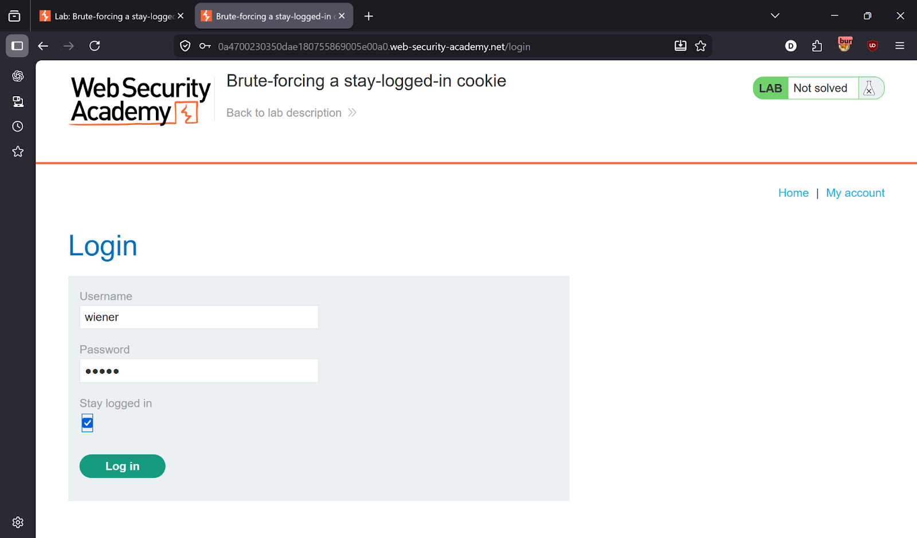
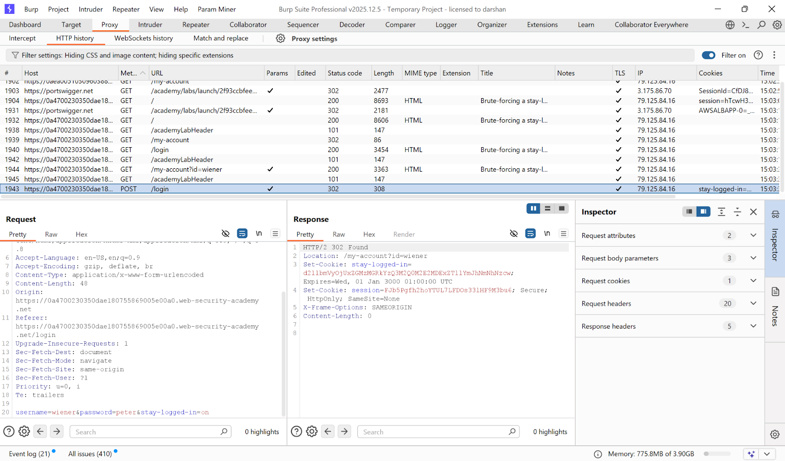

---

Step 2 — Decode the cookie
Base64 decode the `stay-logged-in` cookie value:
```
wiener:51dc30ddc473d43a6011e9ebba6ca770
```
Format: `username:MD5(password)`

---

Step 3 — Send to Intruder
Send the `/my-account?id=carlos` request to **Intruder**. Set payload on the cookie value.

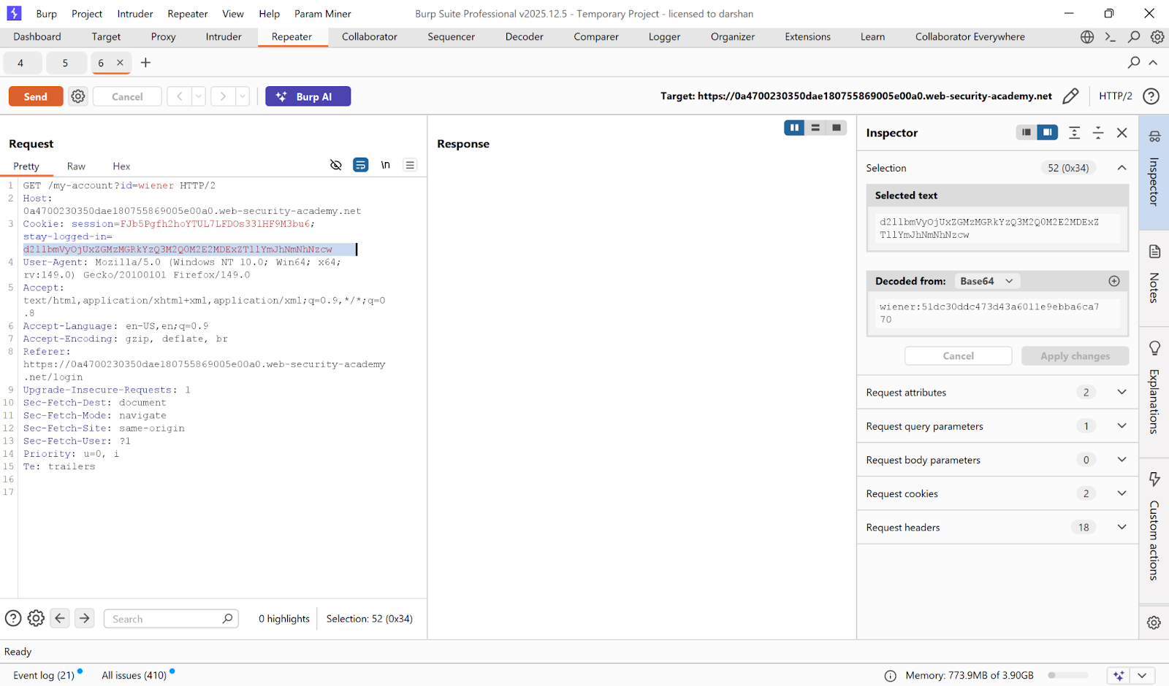
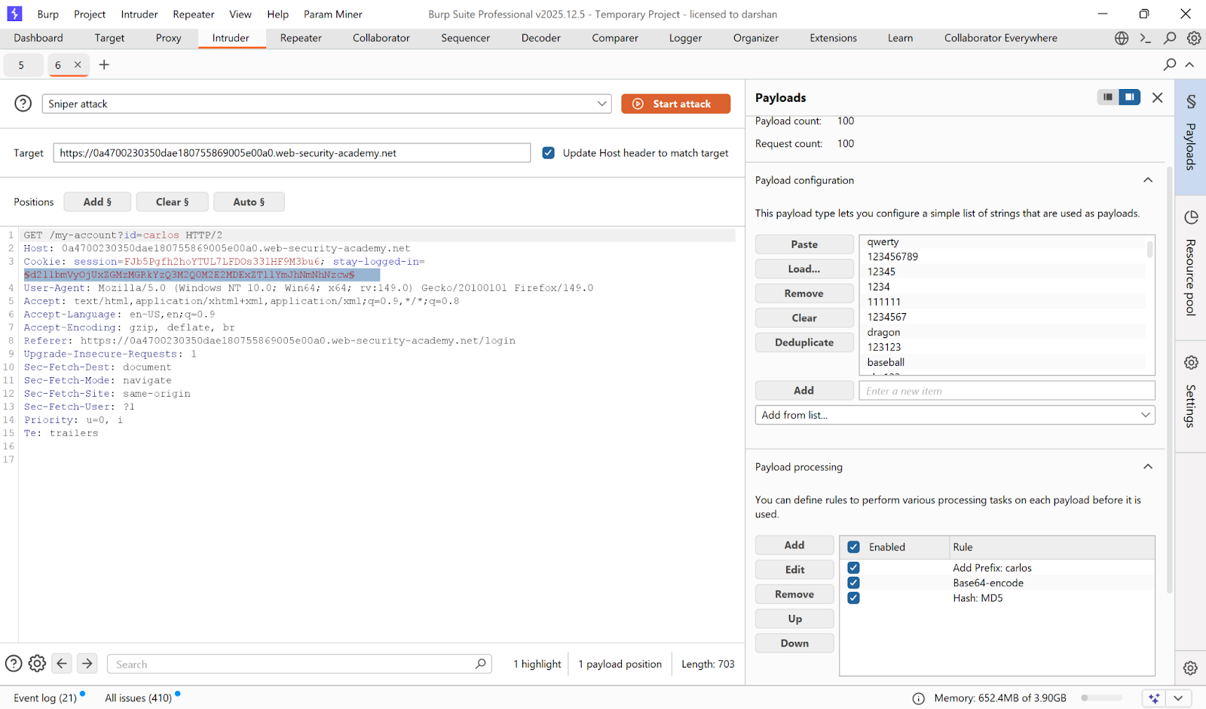

---

Step 4 — Configure payload processing rules
Add these processing rules in order:
1. Hash: **MD5**
2. Add prefix: `carlos:`
3. Encode: **Base64**

Payload list: PortSwigger password wordlist.

---

Step 5 — Identify valid cookie
Look for response containing Carlos's account page.

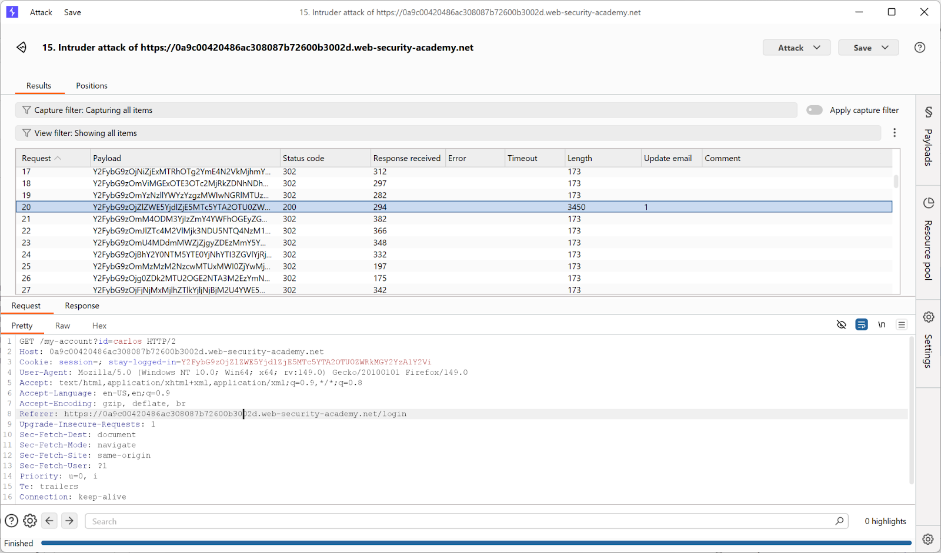

---

Step 6 — Access Carlos's account
Use the valid cookie to access the account.

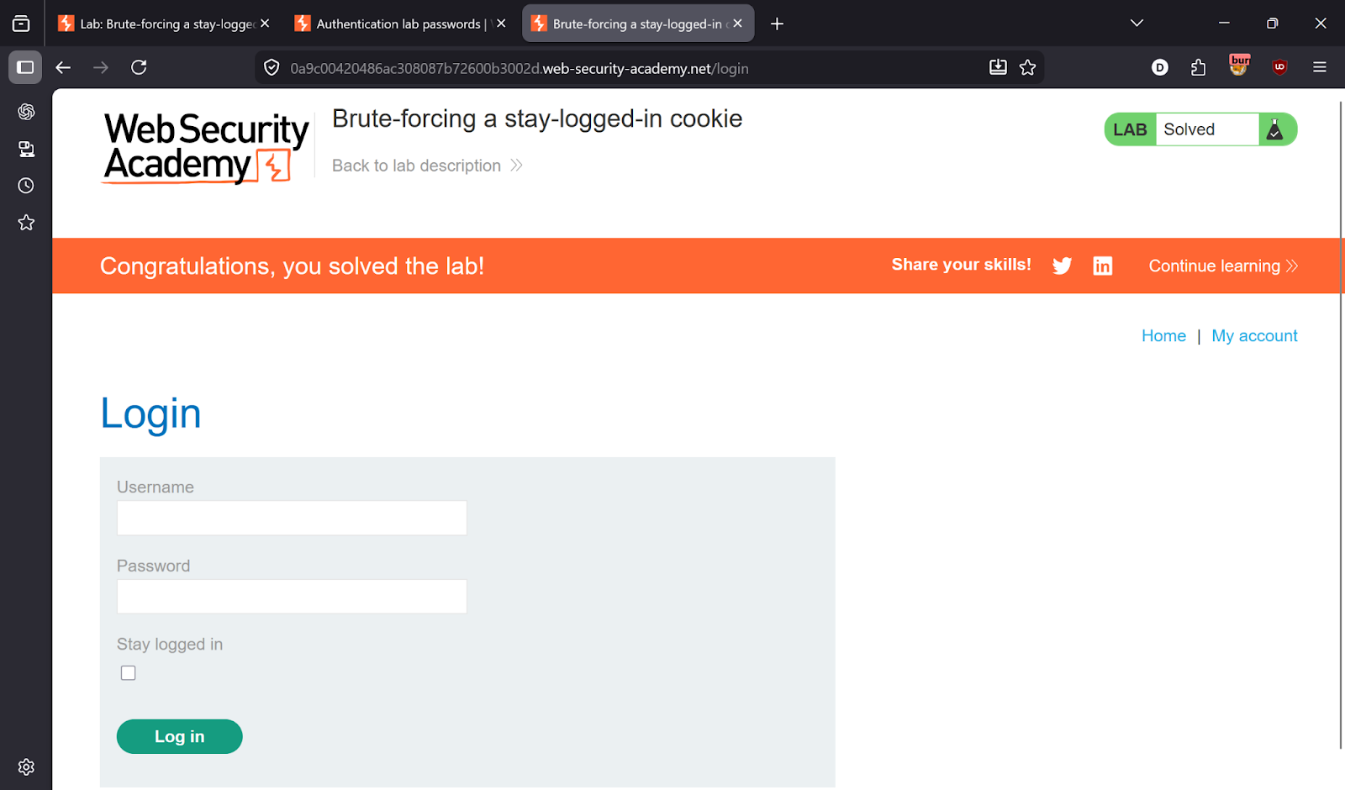

---

✅ Result
Lab solved!

---

💡 Key Takeaway
Stay-logged-in cookies must be cryptographically signed and unpredictable. Never base them on a hash of the password.

